Image Gallery Software

Use-Case-Realization Specification: Search Image

Version <1.0>

Revision History

|  |  |  |  |
| --- | --- | --- | --- |
| **Date** | **Version** | **Description** | **Author** |
| 17/12/2020 | <1.0> | <details> | Do Minh Hieu |
|  |  |  |  |
|  |  |  |  |
|  |  |  |  |

Table of Contents

1. Introduction 2

1.1 Purpose 2

1.2 Scope 2

1.3 Definitions, Acronyms, and Abbreviations 2

1.4 References 2

1.5 Overview 2

2. Use-Case Specification 4

3. Interaction Diagrams 5

4. Class Diagrams 2

3. Derived Requirements 2

Use-Case-Realization Specification: Search Image

# Introduction

## Purpose

This document describes how the Search Image Use-Case is realized within the design model, in terms of collaborating objects.

## Scope

This document applies to the Image Gallery Software which will be developed Group 5C-18.

## Definitions, Acronyms, and Abbreviations

User – a person who use the software.

## References

None.

## Overview

In the following section, Use-Case Realization Specification of the Search Image Use-Case of the Image Gallery Software is provided in detail. The first section is a textual description of the Use-Case specification. The following section contains diagrams (sequence and collaboration diagrams) describing how the use case is realized in terms of collaborating objects. The third section includes class diagrams with relationships that participate in the realization of the use case. The last section is an analysis of all requirements, such as non-functional requirements, on the use-case realization that are not considered in the design model, but that need to be taken care of during implementation.

# Use-Case Specification

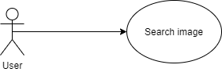

|  |  |
| --- | --- |
| **Name** | Edit Image |
| **Brief Description** | An user edits the picture’s information |
| **Actor** | User |
| **Flow of Events** | |
| **Basic Flow** | |
| 1. User enter keywords match with categories that they want separate by ‘ ‘. 2. Click ‘Search’ button. 3. The system will display all images has categories match with keyword user enter. | |
| **Alterante Flows** | |
| **Title** | **Description** |
| None. |  |
| **Pre-Conditions** | |
| Enter keyword in the field. | |
| **Post-Conditions** | |
| **Title** | **Description** |
| Success | Display all images match with keyword. |
| Failure | “Unavailable” message appears. |
| **Extension Points** | |
| None | |

# Interaction Diagrams

**Sequence Diagram:**

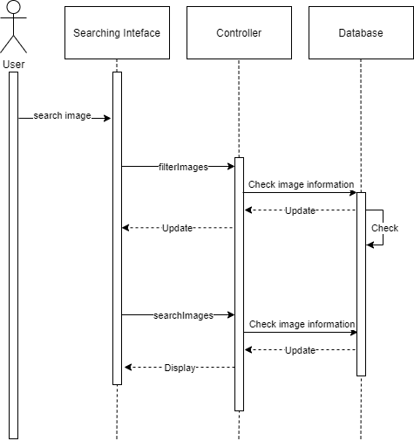

**Collaboration Diagram:** 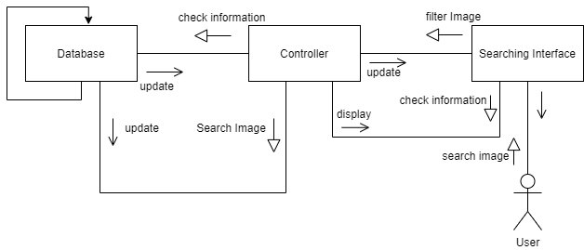

# Class Diagrams

# 

# Derived Requirements

None.